System and Software Architecture Description (SSAD)

Online Wedding Management System

Team12

Amala Rangnekar

System Architect

Rathin Kumar

Project Manager

Rajani Thakur

Requirements Engineer

Divya Yellapragada

Operational Concept Engineer

Kayomars Batliwalla

Feasibility Analyst

Kristen Morse

Life Cycle Planner

Kristopher Reynolds

IIV and V

Image21.png

USC-CSSE

Amala

Table of Contents

Behavior

Design Class Diagram

Create Invitation Sequence Diagram

Login

System Context Diagram

Hardware Component Class Diagram

Software Component Class Diagram

Web Server

Deployment Diagram

Requirement Diagram1

Artifacts and information

Use Cases Grid

Table of Figures

Behavior

Design Class Diagram

Create Invitation Sequence Diagram

Login

System Context Diagram

Hardware Component Class Diagram

Software Component Class Diagram

Web Server

Deployment Diagram

Requirement Diagram1

Artifacts and information

# Behavior

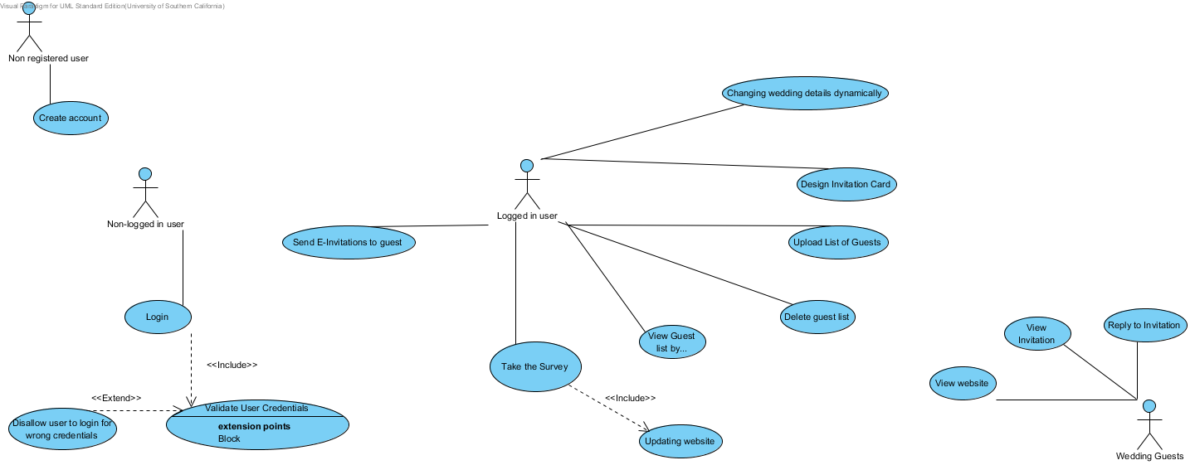

## Details

### Image1.png Non registered user

### Image1.png Non-logged in user

### Image1.png Logged in user

### Image1.png Wedding Guests

### Image2.png View website

#### Use Case Descriptions

|  |  |
| --- | --- |
| Main | |
| **Super Use Case** |  |
| **Author** | amala9 |
| **Date** | Dec 2, 2013 4:47:35 PM |
| **Brief Description** | View couple's website |
| **Preconditions** | Website is designed by couple |
| **Post-conditions** | Website viewed |
| **Flow of Events** | |  |  |  | | --- | --- | --- | |  | Actor Input | System Response | | 1 | Guest clicks on website link in email |  | | 2 |  | Couple's wedding website displayed | |

### Image2.png Delete guest list

#### Use Case Descriptions

|  |  |
| --- | --- |
| Main | |
| **Super Use Case** |  |
| **Author** | amala9 |
| **Date** | Dec 2, 2013 4:29:50 PM |
| **Brief Description** | Delete the guest list |
| **Preconditions** | Guest list uplaoded |
| **Post-conditions** | List deleted |
| **Flow of Events** | |  |  |  | | --- | --- | --- | |  | Actor Input | System Response | | 1 | Couple selects guest list to be deleted and hits delete |  | | 2 |  | Deletes the list | | 3 |  | Confirmation message | |
| **Alternate flow 1** | |  |  |  | | --- | --- | --- | |  | Actor Input | System Response | | 1 | Couple selects guest list to be deleted and hits delete |  | | 2 |  | No delete performed | |

### Image2.png Take the Survey

#### Use Case Descriptions

|  |  |
| --- | --- |
| Main | |
| **Super Use Case** |  |
| **Author** | amala9 |
| **Date** | Dec 1, 2013 6:15:01 PM |
| **Brief Description** | Survey about wedding details |
| **Preconditions** | Registration completed |
| **Post-conditions** | Wedding details recorded in database and displayed for further use-cases/error in saving |
| **Flow of Events** | |  |  |  | | --- | --- | --- | |  | Actor Input | System Response | | 1 | User clicks survey link |  | | 2 | Filling survey form |  | | 3 | Click on Save |  | | 4 |  | Information saved to database | | 5 |  | Confirmation shown | |
| **Alternate flow 1** | |  |  |  | | --- | --- | --- | |  | Actor Input | System Response | | 1 | User clicks survey link |  | | 2 | Filling survey form |  | | 3 | Click on save |  | | 4 |  | error: Information not saved | | 5 |  | Redirect to survey form page. | |

### Image2.png View Guest list by category(event,RSVP status)

#### Use Case Descriptions

|  |  |
| --- | --- |
| Main | |
| **Super Use Case** |  |
| **Author** | amala9 |
| **Date** | Dec 1, 2013 6:13:31 PM |
| **Brief Description** | View the uploaded guest list |
| **Preconditions** | Guest list uploaded |
| **Post-conditions** | Guest list displayed/error message if no list |
| **Flow of Events** | |  |  |  | | --- | --- | --- | |  | Actor Input | System Response | | 1 | Select the criteria by which to view guest list |  | | 2 |  | List displayed | |
| **Alternate flow of event 1** | |  |  |  | | --- | --- | --- | |  | Actor Input | System Response | | 1 | Select the criteria by which to view guest list |  | | 2 |  | Empty list displayed | |

### Image2.png Changing wedding details dynamically

#### Details

|  |  |
| --- | --- |
| Name | Value |
| Preconditions | Design ready for editing |
| Post-conditions | Design details dynamically edited |

#### Use Case Descriptions

|  |  |
| --- | --- |
| Main | |
| **Super Use Case** |  |
| **Author** | amala9 |
| **Date** | Dec 1, 2013 6:05:14 PM |
| **Brief Description** | Edit details on wedding invitation design |
| **Preconditions** | Invitation background selected |
| **Post-conditions** | Details updated |
| **Flow of Events** | |  |  |  | | --- | --- | --- | |  | Actor Input | System Response | | 1 | Couple views their invitation design |  | | 2 | Edit details as per requirement on this design |  | | 3 | Click Save button |  | | 4 |  | Save invitation design | |

### Image2.png View Invitation

#### Details

|  |  |
| --- | --- |
| Name | Value |
| Preconditions | invitation ready |
| Post-conditions | details viewed |

#### Use Case Descriptions

|  |  |
| --- | --- |
|  | |
| **Super Use Case** |  |
| **Author** | amala9 |
| **Date** | Oct 23, 2013 11:06:18 PM |
| **Brief Description** | Guest clicks on the RSVP link in email for more details on the event |
| **Preconditions** | RSVP link received |
| **Post-conditions** | Invitation details viewed |
| **Flow of Events** | |  |  |  | | --- | --- | --- | |  | Actor Input | System Response | | 1 | Guest clicks on invitation link in email |  | | 2 |  | Redirect to couple's website with event details and RSVP form | |
| **Alternate flow 1** | |  |  |  | | --- | --- | --- | |  | Actor Input | System Response | | 1 | Guest clicks on invitation link in email |  | | 2 |  | Error message displayed | |

### Image2.png Reply to Invitation

#### Details

|  |  |
| --- | --- |
| Name | Value |
| Preconditions | invite sent |
| Post-conditions | rsvp received |

#### Use Case Descriptions

|  |  |
| --- | --- |
| Main | |
| **Super Use Case** |  |
| **Author** | amala9 |
| **Date** | Dec 1, 2013 5:55:08 PM |
| **Brief Description** | Respond to the invite |
| **Preconditions** | RSVP link received in email |
| **Post-conditions** | RSVP response recorded in database |
| **Flow of Events** | |  |  |  | | --- | --- | --- | |  | Actor Input | System Response | | 1 | Guest clicks on RSVP link |  | | 2 |  | Redirect to RSVP form page for associated couple | | 3 | Enter and Submit RSVP form details |  | | 4 |  | Confirmation message:data saved | |

### Image2.png Send E-Invitations to guest

#### Use Case Descriptions

|  |  |
| --- | --- |
| Main | |
| **Super Use Case** | send invitations |
| **Author** | amala9 |
| **Date** | Oct 23, 2013 11:01:20 PM |
| **Brief Description** | send invites by email to guests |
| **Preconditions** | guest list uploaded |
| **Post-conditions** | invites sent to guest list/error |
| **Flow of Events** | |  |  |  | | --- | --- | --- | |  | Actor Input | System Response | | 1 | Couple clicks on send invites |  | | 2 |  | Invites sent to guests in emails with invitation link | | 3 |  | Redirected to confirmation screen | |
| **Alternate flow 1** | |  |  |  | | --- | --- | --- | |  | Actor Input | System Response | | 1 | Couple clicks on send invites |  | | 2 |  | Error: No invites sent | | 3 |  | Redirected to invite page with error message 'no guest list to send invites' | |

### Image2.png Upload List of Guests

#### Use Case Descriptions

|  |  |
| --- | --- |
| Main | |
| **Super Use Case** |  |
| **Author** | amala9 |
| **Date** | Dec 1, 2013 6:12:23 PM |
| **Brief Description** | Upload guest list excel sheet |
| **Preconditions** | Logged in user |
| **Post-conditions** | Guest list available for viewing |
| **Flow of Events** | |  |  |  | | --- | --- | --- | |  | Actor Input | System Response | | 1 |  | Presents downloadable template to fill data to user | | 2 | User fills and uploads excel sheet |  | | 3 |  | System parses uplaoded file and saves into database | | 4 |  | Save confirmation message | |
| **Alternate flow 1** | |  |  |  | | --- | --- | --- | |  | Actor Input | System Response | | 1 |  | Presents downloadable template to fill data to user | | 2 | User fills and uploads excel sheet |  | | 3 |  | System parses uploaded file and saves into database | | 4 |  | Error message | |

### Image2.png Design Invitation Card

#### Use Case Descriptions

|  |  |
| --- | --- |
| Main | |
| **Super Use Case** |  |
| **Author** | amala9 |
| **Date** | Dec 1, 2013 6:08:23 PM |
| **Brief Description** | Design the invitation card to be sent to all guests |
| **Preconditions** | Logged in user |
| **Post-conditions** | Invitation saved |
| **Flow of Events** | |  |  |  | | --- | --- | --- | |  | Actor Input | System Response | | 1 | Couple selects invitation background |  | | 2 | Couple clicks save button |  | | 3 |  | System saves background | | 4 |  | System redirects to invitation design page | | 5 | Select components on the background with desired locations |  | | 6 | Click save button |  | | 7 |  | Saves all positions and content | |

### Image2.png Disallow user to login for wrong credentials

#### Details

|  |  |
| --- | --- |
| Name | Value |
| Preconditions | Validation occurred |
| Post-conditions | Login error |

#### Use Case Descriptions

|  |  |
| --- | --- |
| disallow login | |
| **Super Use Case** |  |
| **Author** | amala9 |
| **Date** | Oct 23, 2013 10:41:19 PM |
| **Brief Description** |  |
| **Preconditions** | Validation done |
| **Post-conditions** | User redirected to login page |
| **Flow of Events** | |  |  |  | | --- | --- | --- | |  | Actor Input | System Response | | 1 | Enter credentials |  | | 2 |  | Error message:wrong credentials | | 3 |  | Redirect to login screen | |

### Image2.png Validate User Credentials

#### Extension Points

|  |
| --- |
| Block |

#### Use Case Descriptions

|  |  |
| --- | --- |
| Validate User | |
| **Super Use Case** | Login |
| **Author** | amala9 |
| **Date** | Oct 23, 2013 10:50:11 PM |
| **Brief Description** |  |
| **Preconditions** | Credentials entered(through login) |
| **Post-conditions** | Success/fail |
| **Flow of Events** | |  |  |  | | --- | --- | --- | |  | Actor Input | System Response | | 1 |  | Validate credentials sent by user | | 2 |  | Check with database | | 3 |  | Confirm message and take to home screen | |
| **Alternate flow 1** | |  |  |  | | --- | --- | --- | |  | Actor Input | System Response | | 1 |  | Validate credentials sent by user | | 2 |  | Check with database | | 3 |  | Error message and take to login screen | |

### Image2.png Login

#### Use Case Descriptions

|  |  |
| --- | --- |
| Login | |
| **Super Use Case** |  |
| **Author** | amala9 |
| **Date** | Oct 23, 2013 10:54:28 PM |
| **Brief Description** | For registered users to login into the system |
| **Preconditions** | Credentials entered |
| **Post-conditions** | Allow/disallow |
| **Flow of Events** | |  |  |  | | --- | --- | --- | |  | Actor Input | System Response | | 1 | Enter credential |  | | 2 |  | Validation check:pass | | 3 |  | Confirmation message, redirect to home screen | |
| **Alternate flow 1** | |  |  |  | | --- | --- | --- | |  | Actor Input | System Response | | 1 | Enter credentials |  | | 2 |  | Validation check:fail | | 3 |  | Redirect to login screen with error message displayed | |

### Image2.png Create account

#### Use Case Descriptions

|  |  |
| --- | --- |
| create account | |
| **Super Use Case** |  |
| **Author** | amala9 |
| **Date** | Oct 23, 2013 10:55:43 PM |
| **Brief Description** | Creates user account for a new user |
| **Preconditions** | user account doesn't exist |
| **Post-conditions** | account created/validation error |
| **Flow of Events** | |  |  |  | | --- | --- | --- | |  | Actor Input | System Response | | 1 | user fills registration form and submits it |  | | 2 |  | Validate form:pass | | 3 |  | Registration link sent to user in email | | 4 | User clicks on link |  | | 5 |  | Confirmation: account created. | |
| **Alternate flow 1** | |  |  |  | | --- | --- | --- | |  | Actor Input | System Response | | 1 | user fills registration form and submits it |  | | 2 |  | Validate form:fail | | 3 |  | Registration link sent to user in email | | 4 | User clicks on link |  | | 5 |  | Redirect to form page with error displayed | |
| **Alternate flow 2** | |  |  |  | | --- | --- | --- | |  | Actor Input | System Response | | 1 | user fills registration form and submits it |  | | 2 |  | Validate form:fail | | 3 |  | Display message 'Account already exists' | |

### Image2.png Updating website

#### Use Case Descriptions

|  |  |
| --- | --- |
| Main | |
| **Super Use Case** |  |
| **Author** | home |
| **Date** | Dec 2, 2013 8:36:43 PM |
| **Brief Description** |  |
| **Preconditions** | Website ready and details entered |
| **Post-conditions** | Details updated |
| **Flow of Events** | |  |  |  | | --- | --- | --- | |  | Actor Input | System Response | | 1 | User clicks survey link |  | | 2 | Edit survey information |  | | 3 | Click save |  | | 4 |  | Information saved to database | | 5 |  | Confirmation shown | |
| **Alternate flow1** | |  |  |  | | --- | --- | --- | |  | Actor Input | System Response | | 1 | User clicks survey link |  | | 2 | Edit survey information |  | | 3 | Click save |  | | 4 |  | Information not saved | | 5 |  | Redirected to survey page | |

# Design Class Diagram

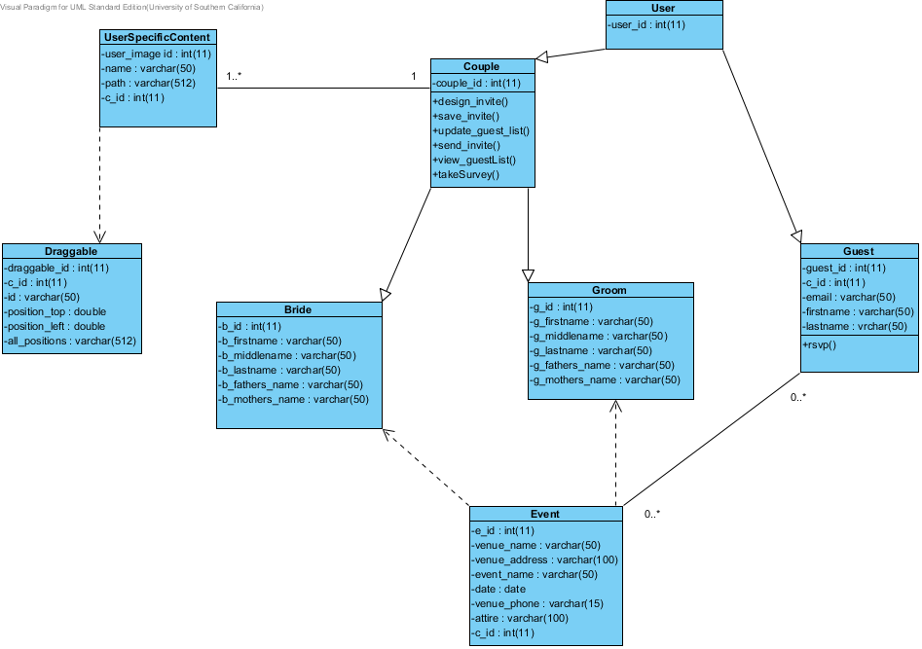

## Details

### Image4.png User

### Image4.png UserSpecificContent

### Image4.png Couple

### Image4.png Draggable

### Image4.png Guest

### Image4.png Groom

### Image4.png Bride

### Image4.png Event

# Create Invitation Sequence Diagram

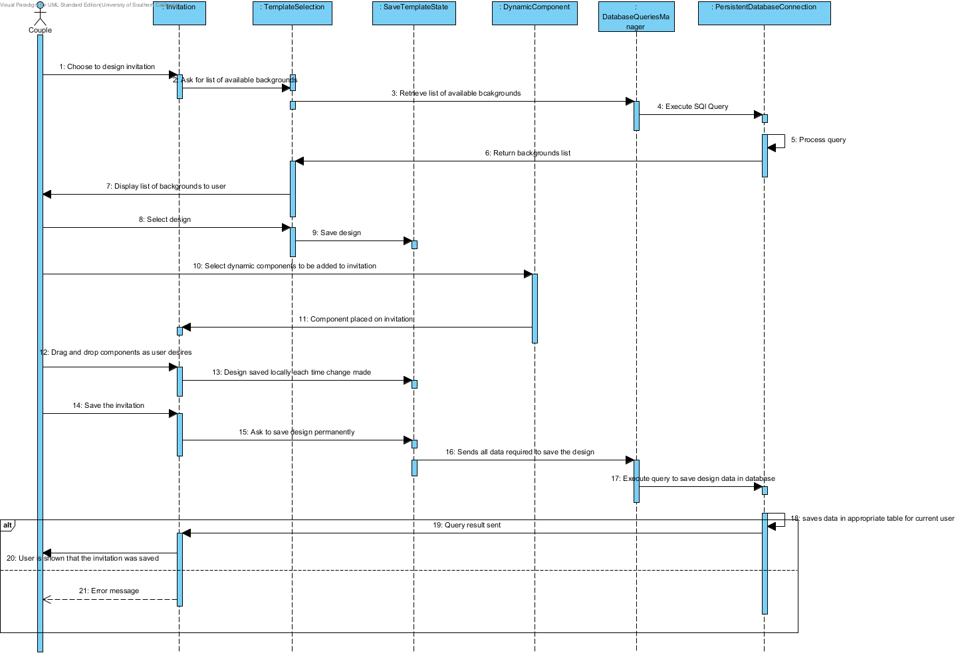

## Details

### Image1.png Couple

### Image6.png : Invitation

### Image6.png : TemplateSelection

### Image6.png : DatabaseQueriesManager

### Image6.png : PersistentDatabaseConnection

### Image6.png : SaveTemplateState

### Image6.png : DynamicComponent

### Image7.png Operand2

### Image7.png Operand

### Image8.png CombinedFragment

# Login

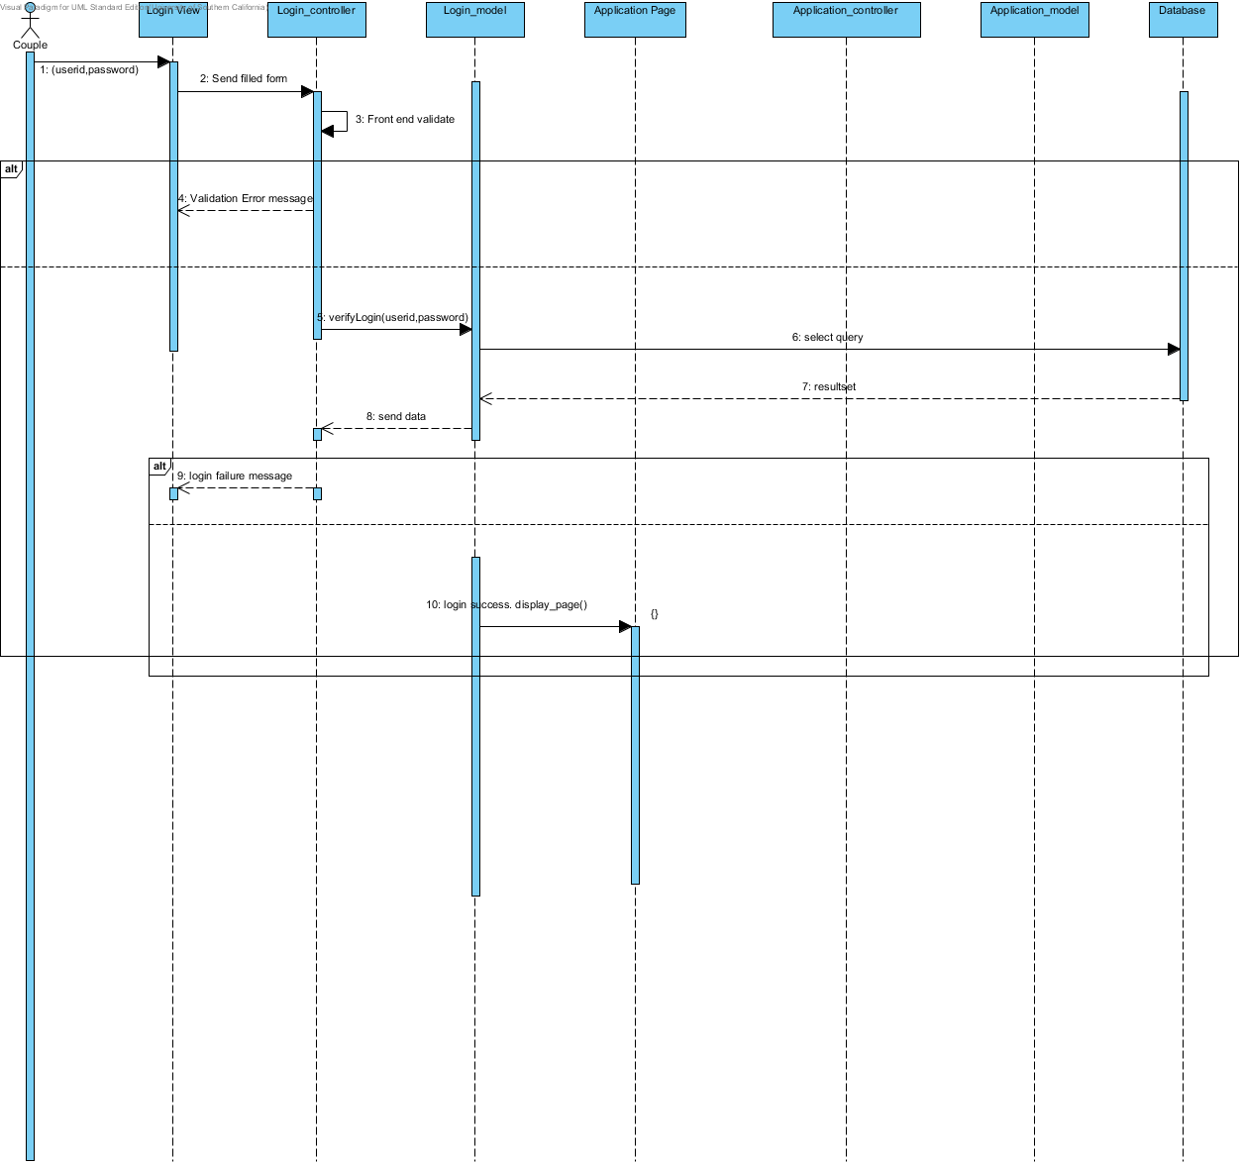

## Details

### Image1.png Couple

### Image6.png Login View

### Image6.png Login_controller

### Image6.png Login_model

### Image6.png Database

### Image6.png Application Page

### Image8.png CombinedFragment2

### Image8.png CombinedFragment

### Image6.png Application_model

### Image6.png Application_controller

# System Context Diagram

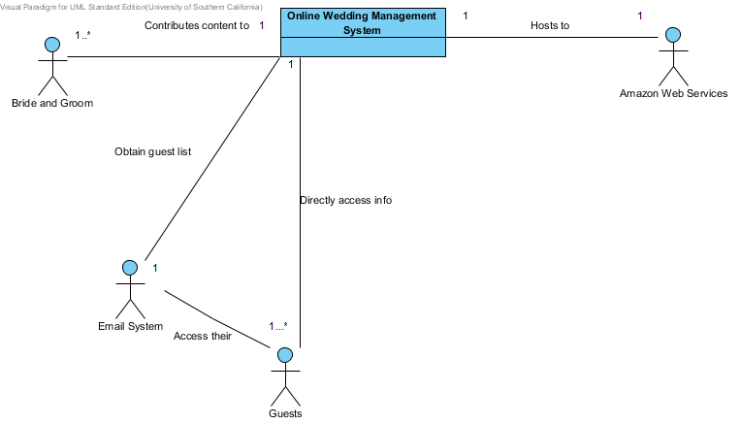

## Details

### Image11.png 1...*

### Image11.png 1..*

### Image11.png *

### Image11.png 1

### Image11.png *

### Image11.png *

### Image4.png Online Wedding Management System

### Image1.png Amazon Web Services

### Image1.png Guests

### Image1.png Email System

### Image1.png Bride and Groom

# Hardware Component Class Diagram

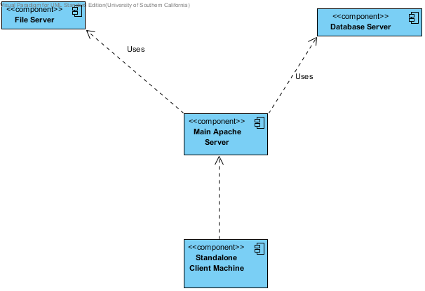

## Details

### Image13.png File Server

### Image13.png Database Server

### Image13.png Main Apache Server

### Image13.png Standalone Client Machine

# Software Component Class Diagram

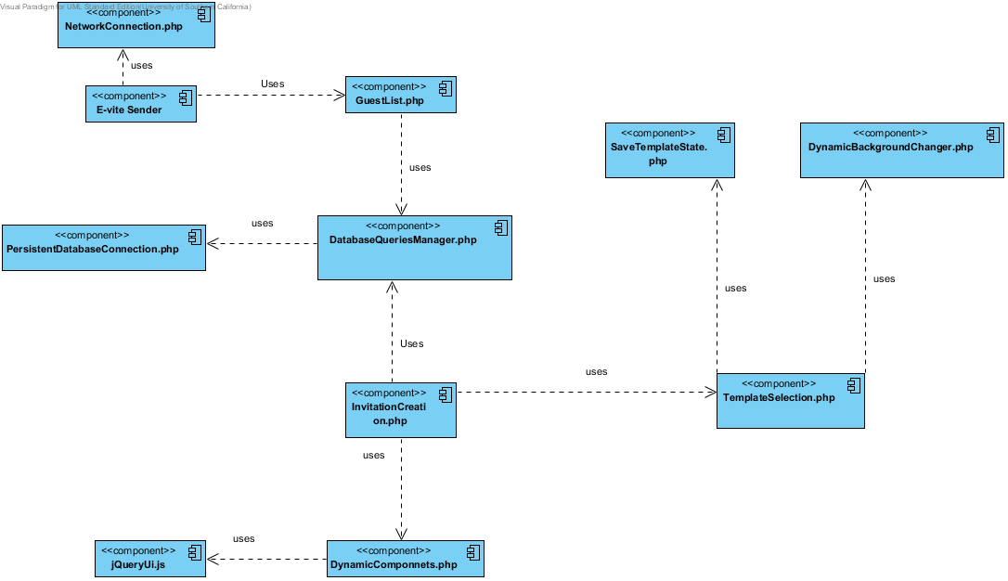

## Details

### Image13.png NetworkConnection.php

### Image13.png GuestList.php

### Image13.png E-vite Sender

### Image13.png SaveTemplateState.php

### Image13.png DynamicBackgroundChanger.php

### Image13.png DatabaseQueriesManager.php

### Image13.png PersistentDatabaseConnection.php

### Image13.png TemplateSelection.php

### Image13.png InvitationCreation.php

### Image13.png jQueryUi.js

### Image13.png DynamicComponnets.php

# Web Server

Image15.png

## Details

### Image13.png Apache HTTPD

# Deployment Diagram

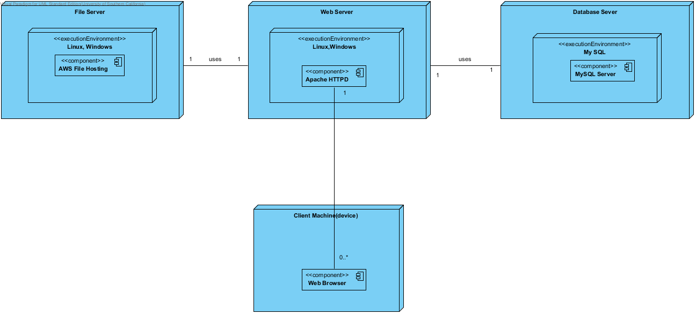

## Details

### Image17.png File Server

### Image17.png Web Server

### Image17.png Database Sever

### Image17.png Linux, Windows

### Image17.png Linux,Windows

### Image17.png My SQL

### Image13.png AWS File Hosting

### Image13.png MySQL Server

### Image13.png Apache HTTPD

### Image17.png Client Machine(device)

### Image13.png Web Browser

# Artifacts and information

